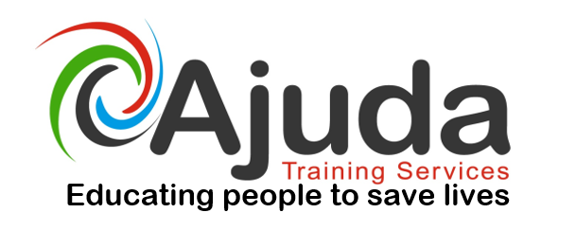

Level 2 Award in Manual Handling
(Modules A&B Inanimate Loads) (QCF)

Manual Handling injuries account to 36% of all reported workplace accidents. The Health & Social Care sector accounts for 54% of all reported manual handling accidents. This course will provide a consistent approach to Manual Handling that ensures best practice in accordance with the All Wales Local Government Manual Handling Training Passport & Information Scheme.

Course Objectives & Learning Outcomes

By the end of the course delegates will have a clear understanding of Manual Handling that ensures best practice in accordance with the All Wales Local Government Manual Handling Training Passport & Information Scheme.

At the end of the course students will be able to:
- Describe the function of the spine
- Examine & Discuss Manual Handling Legislation
- Discuss Company Manual Handling policy’s
- Describe Ergonomics
- Examine and Discuss Manual Handling Risk Assessment
- Discuss safe handling procedures
- Explain the need for effective teamwork & communication
- Demonstrate safe inanimate load handling

This course will be delivered in a classroom environment via power point presentations, discussions, practical demonstrations and lectures. There are two modules to this course which are outlined below:

- Module A - Spinal Awareness, legislation, your authority or company policies, ergonomics, risk assessment, safe handling principles, team handling and communication.
- Module B - Inanimate load handling, practical ergonomics.

Key Facts
QAN: 501/1772/5
GLH: 10
Credit Value: 2
Assessment Method: Multiple Choice Exam & Practical Assessment
Cost: £75 + vat

To book a place onto the above course contact - 02920 576883,

email info@ajuda.org.uk www.ajuda.org.uk

