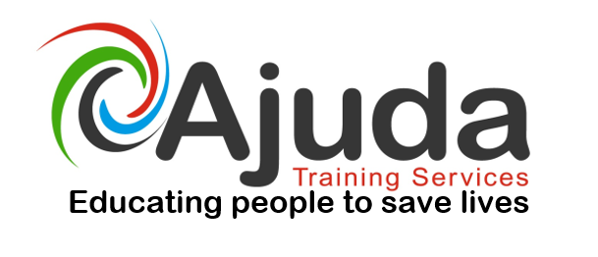

First Aid trainer / Assessor Course

This course is designed to enable the successful candidate to train and assess OFQUAL approved First Aid courses.

Course Objectives & Learning Outcomes

By the end of the course delegates will be equipped to deliver a range of First Aid training programs.
• First aid subject workshops
• First aid changes by the European Resuscitation Council 2015
• 3 day First Aid at Work course delivery, assessment and administration
• 2 day First Aid at Work refresher delivery, assessment and administration
2 day Paediatric First Aid course delivery, assessment and administration
• 1 day Emergency First Aid delivery, assessment and administration
• Course equipment and resource requirements

On successful completion candidates will be qualified to train and assess First Aid courses for OFQUAL / FAIB approved companies, providing the candidate also possess the Level 3 Education and Training qualification or equivalent.
This course will enable you to teach the following courses after completion:
• Level 3 Award in First Aid at Work (QCF) – 3 days
• Level 2 Award in First Aid at Work Refresher (QCF)– 2 days
• Level 2 Award in Emergency First Aid at Work (QCF)– 1 day
• Level 2 Award in Paediatric First Aid (QCF) – 2 days
• Emergency First Aid – 4 Hours
• Heart start Course – 2 hours
Key Facts
GLH: 18
Course Duration: 3 days
Assessment Method: Practical assessments, oral questioning and micro teach.
Cost: £395 + vat

Course Dates:
30th, 31st January & 1st February 2017

To book a place onto the above course contact - 02920 576883,
email info@ajuda.org.uk www.ajuda.org.uk

