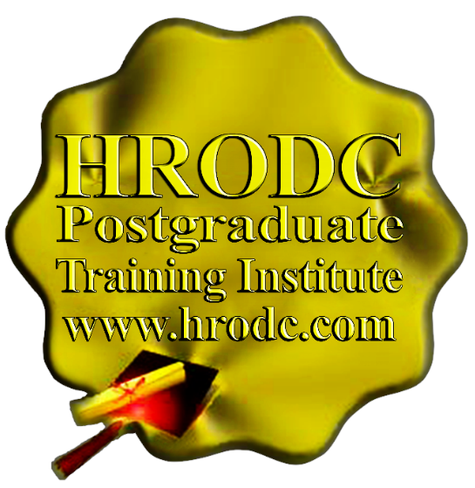


#004
Motivating Workers: Intrinsic and Extrinsic Rewards


Worker Motivation





Motivating Workers: Intrinsic and Extrinsic Rewards
Worker Motivation

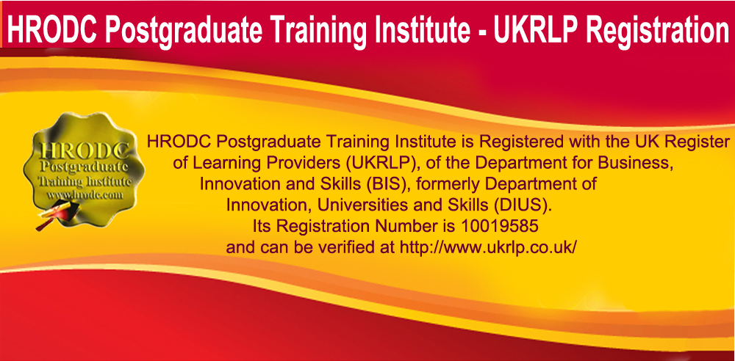

Course Co-ordinator:
Prof. Dr. R. B. Crawford – Director HRODC Postgraduate Training Institute

- PhD (University of London);
- MEd. M. (University of Bath);
- Adv. Dip. Ed. (University of Bristol);
- PGCIS (Thames Valley University);
- ITC (UWI);
- Member of the Standing Council of Organisational Symbolism (MSCOS);
- Member of the Asian Academy of Management (MAAM);
- Member of the International Society of Gesture Studies (MISGS);
- Member of the Academy of Management (MAOM);
- LESAN;
- Professor, HRODC Postgraduate Training Institute;
- Visiting Professor, Polytechnic University of the Philippines (PUP).

For Whom This Course is Designed
This Course is Designed For:

- HR Managers;
- HR Professionals;
- HR Generalists;
- Executives;
- Board of Directors;
- Senior Mangers;
- Middle Managers;
- Junior Managers;
- Supervisors;
- Team Leaders;
- Business Owners;
- Entrepreneurs.

Duration: 5 Days

Cost:
- £4,000.00 Per Delegate for UK Delivery
- £5,000.00 Per Delegate for Delivery outside the UK

Please Note:
- V.A.T. (Government Tax) does not apply to Corporate Sponsored Individuals, taking Programmes or Courses in any location - within or outside the UK.
- It applies only to Individuals and Corporations based in the UK and to Non-UK Individual Residents taking courses in the UK.

Cost includes:

- Free Continuous snacks throughout the Event Days;
- Free Hot Lunch on Event Days;
- Free City Tour;
- Free Stationery;
- Free On-site Internet Access;
- Diploma – Postgraduate – in Worker Motivation; or
- Certificate of Attendance and Participation – if unsuccessful on resit.

HRODC Postgraduate Training Institute’s Complimentary Products include:

- HRODC Postgraduate Training Institute’s Leather Conference Folder;
- HRODC Postgraduate Training Institute’s Leather Conference Ring Binder/ Writing Pad;
- HRODC Postgraduate Training Institute’s Key Ring/ Chain;
- HRODC Postgraduate Training Institute’s Leather Conference (Computer – Phone) Bag – Black or Brown;
- HRODC Postgraduate Training Institute’s 8GB USB Flash Memory Drive, with Course Material;
- HRODC Postgraduate Training Institute’s Metal Pen;
- HRODC Postgraduate Training Institute’s Polo Shirt.
**Please see product images, as a separate file - Complimentary Products For Students and Delegates, from HRODC Postgraduate Training Institute.**

Daily Schedule: 9:30 to 4:30 pm.

Location: Central London and International Locations

Schedule - Part 1:
http://hrodc.com/HRODC_Seminar_Schedule_06-07.International_Seminar_Schedule_UK_Seminars.htm

Click to book this course: http://www.hrodc.com/Course_Booking_Form_London_Dubai_Kuala_Lumpur_Paris_Johannesburg_Cairo_Jeddah_Abu_Dhabi_Kuwait_MBA_MSc_MA_Course.htm

Motivating Workers: Intrinsic and Extrinsic Rewards
Leading to Diploma-Postgraduate in Worker Motivation

Course Objectives

By the conclusion of the specified learning and development activities, delegates will be able to:

- Demonstrate an understanding of the concept of motives and their value in organisational and subsystem effectiveness;
- Distinguish between the different sets of motivation theories, notably content, process and reinforcement;
- Demonstrate their ability to translate motivation theory into practice
- Evaluate the appropriateness of the application of particular theoretical aspects of motivation to specific situations;
- Demonstrate their ability to formulate a comprehensive motivation strategy;
- Critically appraise existing motivation strategy within their organisations, identifying and addressing gaps;
- Formulate a workable motivation strategy;
- Follow the common trends in the popular motivation theories;
- Demonstrate their appreciation of the need for a variance in intrinsic and extrinsic values if motivation;
- Demonstrate how popular motivation theories have contributed to our understanding of worker behaviour;
- Locate performance related pay, productivity bonuses and other remuneration inducement within existing motivation theory;
- Illustrate how the contingency approach to motivation might be applied to different situations;
- Indicate the part that training and development play in worker motivation;
- Manage the process of motivation, taking account of socio cultural and economic differences;
- Manage the motivation process, taking account of the differences in preferences and expectation of workers;
- Apply the ‘equity’ theory to work situation from a ‘differentiation perspective’, rather than an ‘equality perspective;’ and
- Demonstrate the need to balance the ‘individualist’ and ‘collectivist’ perspective to motivation.

- Course Contents, Concepts and Issues

Part 1: Conceptual and Contextual Motivation Issues

- Directing or Leading: Setting The Stage;
- The Conceptual Bases of Motivation;
- Theoretical Bases of Motivation: An Overview;
- Distinguishing Between Knowledge and Skills;
- Competence and Performance: A Conceptual Exploration;
- Is there a Definitive Relationship between Competence and Motivation?

Part 2: Motivation Theories and Their Protagonists (1)

- Content Theories and Some of Their Contributors
- Maslow’s Hierarchy of Needs
- Analysis of Maslow’s Claims
- McClelland's Studies
- Taylor: Money and Motivation
- Motivator-Hygiene Factor: Herzberg’s Contribution

Part 3: Motivation Theories and Their Protagonists (2)

- Process Theories
- Equity Theory
- Goal-Setting Theory
- Expectancy Theory
- Equitable Reward Systems
- Reinforcement Theories

Part 4: Universalist and Contingency Approaches to Motivation

- Motivation and Contingency Theory
- The Contingency Approach to Motivation
- The Collectivist vs. the Individualist Perspective of Motivation
- Common Trends in Motivation Theories
- Intrinsic and Extrinsic Values of Motivation
- Motivation and Worker Behaviour

Part 5: Contextualising Motivation: Intrinsic and Extrinsic Values

- The Extent to Which Salary or Wages Inducement Motivate Workers
- Performance Related Pay (PRP)
- Productivity Bonuses
- Efficiency Gains
- Profit Share
- Social Differentiation in Motivation
- Culture Differentiation in Motivation
- Wealth as a Factor in Motivation
- Class as an Issue in Motivation
- Individual Expectation and Motivation
- Individual Preferences as a Motivating Factor
- Designing an Effective Motivation Strategy

Synopsis of Diploma – Postgraduate, Postgraduate Diploma and
Postgraduate Degree Regulation

Postgraduate Diploma and Diploma – Postgraduate: Their Distinction and Assessment Requirement

Delegates studying courses of 5-9 days duration, equivalent to 30-54 Credit Hours (direct lecturer contact), will, on successful assessment, lead to the Diploma – Postgraduate. This represents a single credit at Postgraduate Level. While 6-day and 7-day courses also lead to a Diploma – Postgraduate, they accumulate 36 and 42 Credit Hours, respectively. Delegates and students who fail to gain the required level of pass, at Postgraduate Level will receive a Certificate of Attendance and Participation. The Certificate of Attendance and Participation will not count, for cumulative purpose, towards the Postgraduate Diploma.

Courses carry varying credit values; some being double credit, triple credit, quad credit and 5-credit, etc. These, therefore, accumulate to a Postgraduate Diploma. As is explained, later, in this document, a Postgraduate Diploma is awarded to students and delegates who have achieved the minimum of 360 Credit Hours, within the required level of attainment.

Credit Value and Credit Hours examples of Diploma – Postgraduate Courses are as follows:

Credit Value | Credit Hours
Single-Credit | 30-36
Double-Credit | 60-72
Triple-Credit | 90-108
Quad-Credit | 120-144
10-Credit (X36 Credit-Hours) to 12-Credit (X30 Credit-Hours) | 360
Other Credit Values are calculated proportionately.

Because of the intensive nature of our courses and programmes, assessment will largely be in-course, adopting differing formats. These assessment formats include, but not limited to, in-class tests, assignments, end of course examinations. Based on these assessments, successful candidates will receive the Diploma – Postgraduate, or Postgraduate Diploma, as appropriate.

In the case of Diploma – Postgraduate, a minimum of 70% overall pass is expected. In order to receive the Award of Postgraduate Diploma, candidate must have accumulated at least the required minimum ‘credit-hours’, with a pass (of 70% and above) in at least 70% of the courses taken.

Delegates and students who fail to achieve the requirement for Postgraduate Diploma, or Diploma - Postgraduate - will be given support for 2 re-submissions for each course. Those delegates who fail to achieve the assessment requirement for the Postgraduate Diploma or Diploma - Postgraduate - on 2 resubmissions, or those who elect not to receive them, will be awarded the Certificate of Attendance and Participation.

Diploma – Postgraduate, Postgraduate Diploma and
Postgraduate Degree Application Requirements

Applicants for Diploma – Postgraduate, Postgraduate Diploma and Postgraduate Degrees are required to submit the following documents:
- Completed Postgraduate Application Form, including a passport sized picture affixed to the form;
- A copy of Issue and Photo (bio data) page of the applicant’s current valid passport or copy of his or her Photo-embedded National Identity Card;
- Copies of credentials mentioned in the application form.

Admission and Enrolment Procedure

- On receipt of all the above documents we will make an assessment of the applicants’ suitability for the Programme for which they have applied;
- If they are accepted on their Programme of choice, they will be notified accordingly and sent Admission Letters and Invoices;
- One week after the receipt of an applicant’s payment or official payment notification, the relevant Programme Tutor will contact him or her, by e-mail or telephone, welcoming him or her to HRODC Postgraduate Training Institute;
- Non-European Students will be sent immigration documentation, incorporating a Visa Support Letter. This letter will bear the applicant’s photograph and passport details;
- Applicants will be notified of the dates, location and venue of enrolment and orientation;
- Non-UK students will be sent general information about ‘student life’ in the UK and Accommodation details.

Modes of Study for Postgraduate Diploma Courses

There are three delivery formats for Postgraduate Diploma Courses, as follows:
- Intensive Full-time Mode (3 months);
- Full-time Mode (6 month);
- Video-Enhanced On-Line Mode.
Whichever study mode is selected, the aggregate of 360 Credit Hours must be achieved.

Cumulative Postgraduate Diploma Courses

All short courses can accumulate to the required number of hours, for the Postgraduate Diploma, over a six-year period from the first registration and applies to both general and specialist groupings. In this regard, it is important to note that short courses vary in length, the minimum being 5 days (Diploma – Postgraduate) – equivalent to 30 Credit Hours, representing one credit. Twelve 5-day short courses, representing twelve credits or the equivalent of 360 Credit Hours are, therefore, required for the Award of Postgraduate Diploma.

A six-day course (Diploma – Postgraduate) is, therefore, equivalent to 36 hours Credit Hours, representing one credit. Therefore, ten short courses, of this duration, equates to the required 360 Credit Hours, qualifying for the Award of Postgraduate Diploma. While double-credit courses last between ten and fourteen days, triple-credit courses range from fifteen to nineteen days. Similarly, quad-credit courses are from sixteen to nineteen days. On this basis, the definitive calculation on the Award requirement is based on the number of hours studied (aggregate credit-value), rather than merely the number of credits achieved. This approach is particularly useful when a student or delegate studies a mixture of courses of different credit-values.

For those delegates choosing the accumulative route, it is advisable that at least two credits be attempted per year. This will ensure that the required number of credit hours for the Postgraduate diploma is achieved within the six-year time frame.

Progression to Postgraduate Degree – MA, MBA, MSc

- On the successful completion of the Postgraduate Diploma, delegates may register for the Masters Degree, after their successful completion of Course #7: Research Project: Design, Conduct & Report.

- The Delegates’ Degree Registration Category will be dictated by the courses or modules studied at Postgraduate Diploma Level. The categories relate to Master of Business Administration (MBA); Master of Arts (MA) Master of Science (MSc); Executive Master of Business Administration (Executive MBA). Additional details are provided in the document entitled: regulation For HRODC Postgraduate Training Institute Diploma – Postgraduate - Postgraduate Diploma and Masters Degree – MA, MBA, MSc.

Terms and Conditions

HRODC Policy Terms and Conditions are Available for viewing at: http://www.hrodc.com/COSTS.htm
Or Downloaded, at: http://www.hrodc.com/Brochure_Download_Centre.Company_Brochures_Seminar_Brochures_Seminar_Schedule.htm
The submission of our application form or otherwise registration by of the submission of a course booking form or e-mail booking request is an attestation of the candidate’s subscription to our Policy Terms and Conditions, which are legally binding.

