Programme Specification
Contents
Key Information 1
The University of Aberdeen 2
Programme Overview 2
What you’ll study 2
Block 1 2
Accounting for Finance 3
Economics for Finance 3
Quantative Techniques 3
Block 2. 3
Financial Analysis and Markets 3
Economics 3
Portfolio Analysis 3
Block 3 3
Ethics 3
Advanced Financial Analysis 3
CFA 1 3
Block 4 3
Personalise Your MSc 3
CFA 2 3
Dissertation/ Project Work 4
University Event 4
Year Schedule 4
How does it work? 5
Assessment 6
Technology Requirements 6
Fees and Funding 6
Entry Requirements 7
Language Requirements 7
Careers 7

Key Information

Duration
Study Mode
Part Time- 15 hours per week
Start Dates
January, July
Learning Mode
Online Delivery
Awards
MBA- 180 credits
Pg Dip- 120 credits
Pg Cert- 60 credits
Modules

The University of Aberdeen

Founded in 1495, the University has a proud tradition of academic excellence and is consistently ranked in the top 1% of universities in the world. A traditional seat of learning, the University of Aberdeen is Scotland’s third oldest university and the fifth oldest in the UK.
The University boasts five Nobel Prize winners.

SHORT PROGRAMME DESCRIPTION

You have the opportunity to study this prestigious programme online; to combine online study with a choice of face-to- face elements giving you the flexibility to manage your studies alongside your other professional commitments, and to tailor your study patterns to suit your requirements. You may also choose to study the complete programme entirely online. Should you choose this option, you will graduate with exactly the same award as those studying on campus.

Programme Overview

I think this should include info about the CFA and the options if you don’t wish to study this

What you’ll study

Block 1
This block explores….
To do so, you will examine:

Accounting for Finance
Module Description

Economics for Finance
Module Description

Quantative Techniques
Module Description

Block 2.

Financial Analysis and Markets
Module Description

Economics
Module Description

Portfolio Analysis
Module Description

Block 3
In this block you will

Ethics
Module Description

Advanced Financial Analysis
Module Description

CFA 1

Block 4

Personalise Your MSc

CFA 2
Module Description

Dissertation/ Project Work
Module Description

University Event

You will have the opportunity to attend at least one face to face event at the University of Aberdeen, where you will meet faculty staff and fellow students. At the event, you will be able to draw together the learning blocks of the programme:
Ideas
Innovation and Understanding
Process and Practice
Context and Implementation
At the event, you will work in groups to find creative solutions to real-life organisational problems. However, please note that while students are encouraged to attend at any point in the programme, your attendance at this event is not mandatory and it is not linked to a specific module.
Throughout the programme, we may offer other additional opportunities to attend similar events. These events may be held at the University, or locally in other areas of the world, particularly where we may have larger groups of students from one country or specific territory studying at the same time.
Of course you may also choose to study some parts of the programme by attending the University.

Year Schedule

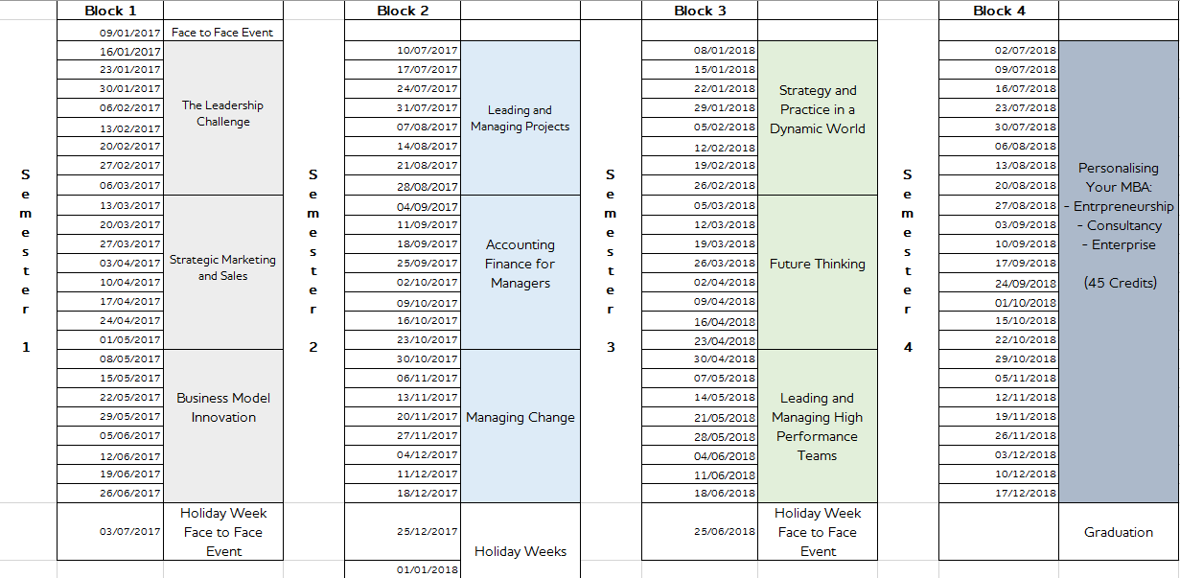

How does it work?
The provision of an authentic, fulfilling learning experience underpins our MBA: you will be challenged to put your new skills and knowledge into practice as quickly as possible through a wide range of activities including:

- Both individual and collaborative activities and challenges
- Digital discussion groups
- Creating new media such as wikis, blogs and vlogs
- Virtual field trips to leading organisations
- Guided reading of key papers
- Master classes with leading experts
- Simulations

The University of Aberdeen MBA is delivered through our online, interactive learning platform, one which mirrors the digital environments used by today’s leading corporations and business organisations. Therefore, in addition to developing new business skills, you will learn how to communicate effectively as a digitally competent manager, one who is experienced in the technologies and processes involved when working with their peers in a global business environment.
As a University of Aberdeen MBA student you will have a secure, personal online space where you will be able to communicate with your tutors, Executive Fellows and other MBA students to form a global MBA community.

There are no fixed-time lectures or tutorials, giving you optimum flexibility. You can access your learning materials at any time, and benefit from unlimited one-to-one tuition, feedback and support.
At the University of Aberdeen, we acknowledge that our MSc candidates may include working professionals with external commitments. The flexibility of our online provision recognises this and gives you the opportunity to manage your own learning around fixed module start dates and assessment submission dates.

Due to the authentic nature of the programme you will be able to link your studies to your own professional work. This will enable you to apply your newly developed knowledge and skills immediately and in a professional context.

Assessment
All of our modules are assessed …

Technology Requirements
Computer
Mac or PC
While we recommend that you use a PC or Mac, the Study Site is also mobile and tablet compatible.
Browser
Firefox or Chrome
Broadband
8Mbps download/ 5Mpbs upload
Equipment
Webcam
Microphone and speakers

Fees and Funding

Tuition Fee-
You can pay for the programme in:
Two instalments of
Four instalments of
Paying in instalments may be subject to an administration fee.

University of Aberdeen Alumni will receive a 20% scholarship towards their Tuition Fee.
Electing to attend face to face events will incur an additional charge.

Entry Requirements

We consider all applicants on an individual basis and welcome applications from those with non-standard qualifications and from a variety of backgrounds.

However, normally to be eligible to enrol you would have a good first degree (equivalent to a British Second-class Honours degree) in any discipline.

Language Requirements

All applicants must provide evidence that their command of English will enable them to study the University of Aberdeen MBA effectively.
English language skills are assessed within the online admissions process and, if requested, during an online interview.
If after assessing your application, we need further evidence that your English language skills are at an appropriate level for entry to the MBA programme, we may ask you to take one of the recognised English language tests such as IELTS, and the following scores will be required:

Listening |  | 5.5 or above
Reading |  | 6.0 or above
Speaking |  | 5.5 or above
Writing |  | 6.0 or above
Overall |  | 6.5

Careers

